iLETU
Software Design Document
Version 1
September 24, 2013

Prepared for
COSC 4853 - Software Engineering II
LeTourneau University
2100 S Mobberly Ave.
Longview, TX 75607

- Scope
  - System objectives
This document describes the preliminary design of the iLETU iPhone app. iLETU was originally created by Dustin Masters, but it is in severe need of an update. The goal of this project is to improve on the original design, add new features, fix bugs, and incorporate LeTourneau branding.
  - Hardware, software, and human interfaces
This software will run on an iPhone or iPad. iLETU will use a storyboard for the human interface of both versions.
  - Major software functions
The software will have 11 distinct purposes. These purposes take the form of views in the application. All requirements are related to one or more specific views. All classes with the exception of the App Delegate and the View Controllers can be traced to one or more specific views. The views are as follows:
- About
- Announcements
- Campus Bullet
- Calendar
- Dining Services
- Floor Plans
- Hours
- Intramurals
- Online
- Schedule
- Yellowjacket News
See Section 5, Views, for more information.
  - Externally defined database
The application will access the following types of external data:
- RSS Feeds
- HTML Pages
Some of the pages will require authentication through a HTTP challenge, Javascript, or HTML Post. See Section 5, Views, for information on each specific View and Appendix B – Use Case Diagram for an overview of each protocol.

  - Major design constraints, limitations
The application will follow current Apple development human interface standards:
    - Deference – The UI helps users to understand the content and never competes with it.
      - Take advantage of the whole screen
Don’t feel the need to put content in boxes; consider letting it stretch across the whole page
      - Reconsider visuals that add realism
Stay away from unnecessary effects such as shadows that clutter the display
    - Clarity – Focus on functionality and keep it simple. Use visuals carefully and make sure icons and text are crisp and lucid.
      - Use negative space effectively
Negative space makes the app seem more efficient and draws attention to important content
      - Use the system fonts for readability
      - Embrace borderless buttons
Use appropriate titles, context, and color to indicate interactivity
    - Depth – Use layers and motion to heighten the user’s experience
      - Use transitions to emphasize relationships
      - Make important content pop out into the foreground

- Reference Documents
  - Sources for existing software documents
  - Documentation of system
- iLETU SRS Version 1. 2013-09-02.
  - Sources for technical reference documents
- iOS Developer Library. Designing for iOS 7. 2013-09-18. <https://developer.apple.com/library/ios/documentation/UserExperience/Conceptual/MobileHIG/index.html#//apple_ref/doc/uid/TP40006556>
- Drew Sikora. Using PDL for Code Design and Documentation. Gamedev.net. 2001-06-13. < http://www.gamedev.net/page/resources/_/technical/general-programming/using-pdl-for-code-design-and-documentation-r1384>
- Design Description
  - Data description
    - Review of data flows
The iLETU app is driven by the letuiphoneAppDelegate. This class has methods that are called when the app is opened, terminated, put in the background, and brought to the foreground. When the app is opened, the application:didFinishLaunchingWithOptions: method is called and assigns the program a splitViewController if the device is an iPad or [a similar controller that appears as a menu that comes from the left of the screen when a button is pressed (more research is needed on this subject)] if the device is an iPhone; each controller puts a navigation pane on the left side of the screen. When the app is closed or put in the background, the applicationDidEnterBackground method is called which saves the order of the tabs and the currently opened tab for use on the next launch. When the app is put in the foreground, the applicationWillEnterForeground method is called. This method restores the tab order and current tab from the previous session.
The main controller refers to a storyboard file, mainStoryBoard_iPad.storyboard or mainStoryBoard_iPhone.storyboard respectively, for the views and the content of each view. The storyboard is a computer generated document that stores information on every view and its content. Refer to Section 4, Views, for detailed information about each view and its members.
    - Review of data structures
  - Derived program structure
  - Interfaces within the structure

- ECM
  - Views
    - Announcements
      - Processing narrative with cross reference to SRS
This view inherits functionality from the RSSView class, Section 4.2.1.
When the Announcements View is activated by the Application Delegate, the software shall connect to the announcements RSS feed at http://letustartpage.blogspot.com/feeds/posts/default?alt=rss. The software will load each article into the Announcement data structure, which has a field for the title, date, and body of the article. See Section 4.2.1.1 for more detail about the feed and list.
      - Interface description
The Announcements view inherits interfaces from the RSSView class detailed Section 4.2.1.2.
      - Design language (or other) description
When the view is opened:
        - Set the title of the window to “Announcements”
        - Set the URL of the RSS feed to the one listed in the processing narrative
        - Follow the normal steps to set up an RSS viewer with the URL and download the articles
        - For each article, put the title and date in a list
      - Modules used
This view inherits from the RSSView.
      - Data organization
This class will depend on a delegate to control its flow. The delegate will handle transitions between views. The style of the delegate will change depending on if the device is in iPhone or iPad. It will also inherit data organization from the RSSView class, Section 4.2.1.5.
      - Comments
    - Online
      - Processing narrative with cross reference to SRS
        - Input
        - Internal Datastructures/Database interaction
        - Output
      - Interface description
      - Design language (or other) description
      - Modules used
      - Data organization
      - Comments
    - Calendars
      - Processing narrative with cross reference to SRS
        - Input
        - Internal Datastructures/Database interaction
        - Output
      - Interface description
      - Design language (or other) description
      - Modules used
      - Data organization
      - Comments
    - Dining Services
      - Processing narrative with cross reference to SRS
This view inherits functionality from the RSSView class, Section 4.2.1.
When the Dining Services View is activated by the Application Delegate, the software shall connect to the announcements RSS feed at http://legacy.cafebonappetit.com/rss/menu/147. The software will load each article into the Dining Services data structure, which has a field for the title, date, and body of the article. See Section 4.2.1.1 for more detail about the feed and list.
      - Interface description
The Dining Services view inherits interfaces from the RSSView class detailed Section 4.2.1.2.
      - Design language (or other) description
When the view is opened:
        - Set the title of the window to “Dining Services”
        - Set the URL of the RSS feed to the one listed in the processing narrative
        - Follow the normal steps to set up an RSS viewer with the URL and download the articles
        - For each article, put the title and date in a list
      - Modules used
This view inherits from the RSSView.
      - Data organization
This class will depend on a delegate to control its flow. The delegate will handle transitions between views. The style of the delegate will change depending on if the device is in iPhone or iPad. It will also inherit data organization from the RSSView class, Section 4.2.1.5.
      - Comments
    - Hours
      - Processing narrative with cross reference to SRS
        - Input
        - Internal Datastructures/Database interaction
        - Output
      - Interface description
      - Design language (or other) description
      - Modules used
      - Data organization
      - Comments
    - Campus Bullet
      - Processing narrative with cross reference to SRS
This view inherits functionality from the RSSView class, Section 4.2.1.
When the Campus Bullet View is activated by the Application Delegate, the software shall connect to the announcements RSS feed at http://campusbullet.net/home/category/all/?feed. The software will load each article into the Announcement data structure, which has a field for the title, date, and body of the article. See Section 4.2.1.1 for more detail about the feed and list.
      - Interface description
The Campus Bullet view inherits interfaces from the RSSView class detailed Section 4.2.1.2.
      - Design language (or other) description
When the view is opened:
        - Set the title of the window to “Campus Bullet”
        - Set the URL of the RSS feed to the one listed in the processing narrative
        - Follow the normal steps to set up an RSS viewer with the URL and download the articles
        - For each article, put the title and date in a list
      - Modules used
This view inherits from the RSSView.
      - Data organization
This class will depend on a delegate to control its flow. The delegate will handle transitions between views. The style of the delegate will change depending on if the device is in iPhone or iPad. It will also inherit data organization from the RSSView class, Section 4.2.1.5.
      - Comments
    - Yellowjacket
      - Processing narrative with cross reference to SRS
This view inherits functionality from the RSSView class, Section 4.2.1.
When the Yellowjacket View is activated by the Application Delegate, the software shall connect to the announcements RSS feed at http://letuyellowjacket.org/feed/. The software will load each article into the Announcement data structure, which has a field for the title, date, and body of the article. See Section 4.2.1.1 for more detail about the feed and list.
      - Interface description
The Yellowjacket view inherits interfaces from the RSSView class detailed Section 4.2.1.2.
      - Design language (or other) description
When the view is opened:
        - Set the title of the window to “Yellowjacket”
        - Set the URL of the RSS feed to the one listed in the processing narrative
        - Follow the normal steps to set up an RSS viewer with the URL and download the articles
        - For each article, put the title and date in a list
      - Modules used
This view inherits from the RSSView.
      - Data organization
This class will depend on a delegate to control its flow. The delegate will handle transitions between views. The style of the delegate will change depending on if the device is in iPhone or iPad. It will also inherit data organization from the RSSView class, Section 4.2.1.5.
      - Comments
    - About
      - Processing narrative with cross reference to SRS
        - Input
        - Internal Datastructures/Database interaction
        - Output
      - Interface description
      - Design language (or other) description
      - Modules used
      - Data organization
      - Comments
    - Intramurals
      - Processing narrative with cross reference to SRS
When the Intramurals View is activated by the Application Delegate, the software shall connect to the designated URL at https://www.imleagues.com/School/Home.aspx?SchID=39d7b8cb08db465ab4f27a061607a7c4. The software shall display the page in the application.
      - Interface description
The Intramurals view does not inherit any interfaces.
      - Design language (or other) description
When the view is opened:
        - Set the title of the window to “Intramurals”
        - Set the URL to the one listed in the processing narrative
        - Show the page corresponding to the URL
      - Modules used
There are no modules used
      - Data organization
This class will depend on a delegate to control its flow. The delegate will handle transitions between views. The style of the delegate will change depending on if the device is in iPhone or iPad.
      - Comments
    - Schedule
      - Processing narrative with cross reference to SRS
When the Schedule View is activated by the Application Delegate for the first time, it shall connect to the designated URL at http://www.letu.edu/academics/lusa/. Once the user enters all of their classes, the software shall save the URL and open that URL from then on.
      - Interface description
The Schedule view does not inherit any interfaces
      - Design language (or other) description
When the view is opened:
        - Set the title of the window to “Schedule”
        - Set the URL to the one listed in the processing narrative
        - Show the page corresponding to the URL
When the user finishes entering their classes:
        - Save the new URL and replace the one listed in the processing narrative
      - Modules used
There are no modules used
      - Data organization
This class will depend on a delegate to control its flow. The delegate will handle transitions between views. The style of the delegate will change depending on if the device is in iPhone or iPad.
      - Comments
    - Floor Plan
      - Processing narrative with cross reference to SRS
        - Input
        - Internal Datastructures/Database interaction
        - Output
      - Interface description
      - Design language (or other) description
      - Modules used
      - Data organization
      - Comments
  - Supporting entities
    - RSSView class
      - Processing narrative with cross reference to SRS
This entity provides the framework to download and display RSS feeds. It takes a URL and has methods that download the feed. After the feed is finished downloading, each item is put in a single column table view. The articles will all be initially marked as unread by putting a dot next to the item. As soon as an unread item is opened, the item should be marked as read and the dot removed. The list will then disappear, and the selected article will display on the screen until the user presses the back button which will send the user back to the list. If the user presses the refresh button on the upper right corner of the screen, the app will re-download all of the information and mark all articles as unread.
      - Interface description
The RSSView will interface with the controller through a set of delegates, and each delegate requires the view to implement predefined functions. The delegates are listed below, and they will be addressed in more detail in a later version of this document.
- UITableViewDelegate
- NSXMLParserDelegate
It will also have the following methods to interface with its parent container:
- (void)refreshContent
- (void)appendWithURL:(NSString*)url
- (void)screenLoading:(BOOL)loading
      - Design language (or other) description
When loading data from an RSS feed:
        - Attempt to connect to the feed.
        - If the connection fails, show an error explaining the problem.
        - Else, for each article download its title, link, date, and summary.
        - Put the articles in a list ordered chronologically, newest at the top
        - Mark all articles as unread
When the refresh button is pressed:
- Empty the list of articles.
- Load the data from the feed again.
When an article is selected from the list:
- Transition to a page showing the article title, link, date, and summary.
When the back button is pressed while viewing an article:
- Transition back to the list of articles
- Mark the article viewed as read
      - Modules used
This class is a subclass of UIViewController, a standard class in the iOS library.
      - Data organization
The RSS reader parses one article at a time and adds it to an array. This class will not be used directly in the app but has many subclasses that are used in views. These are the views that inherit from RSSView:
- Announcements
- Calendar
- Campus Bullet
- Yellowjacket
      - Comments
This class is never used directly, but many of the views are subclasses of this one. The RSSView leaves the decision about the content displayed in the table to its subclasses.

- File Structure and Global Data
  - External File Structure
    - Logical Structure
The data that will be pulled from an external source will be stored as a standard RSS feed. Standard tags will be used in order to facilitate the parsing of the file later. Tags shall be nested in order to group related information.
    - Logical Record Description
The RSS feeds will all contain several sections, including the title of the element, the date that it was posted on, the link that it forwards to, and the body containing the actual information for each element.
    - Access Method
The RSS feed will be accessed and downloaded by the device. Once it is stored locally, it will be parsed for information, and the elements will have their title displayed in a list that is sorted by date. Each element will have all parsed associated information stored with it. When an element is selected from the list, a new screen will open up displaying the body content.
  - Global Data
For the auto-login online services, the username and password of the user will be saved in the user preferences storage area of the device. When they need to be accessed to sign in to the different online services, the pages will be able to retrieve these strings and use them to authenticate the user.
  - File and Data Cross Reference
There will be no data that will be modified from multiple locations. The only stored data that will be modified is the login information, and it will only be modified from the auto-login page. RSS files will only be stored on a per-session basis. They will be overwritten when the refresh button is pressed.

- Test Provisions
  - Test guidelines
  - Integration strategy
  - Special considerations

- Packaging
  - Special program overlay provisions
  - Transfer considerations

- Special Notes

- Appendices
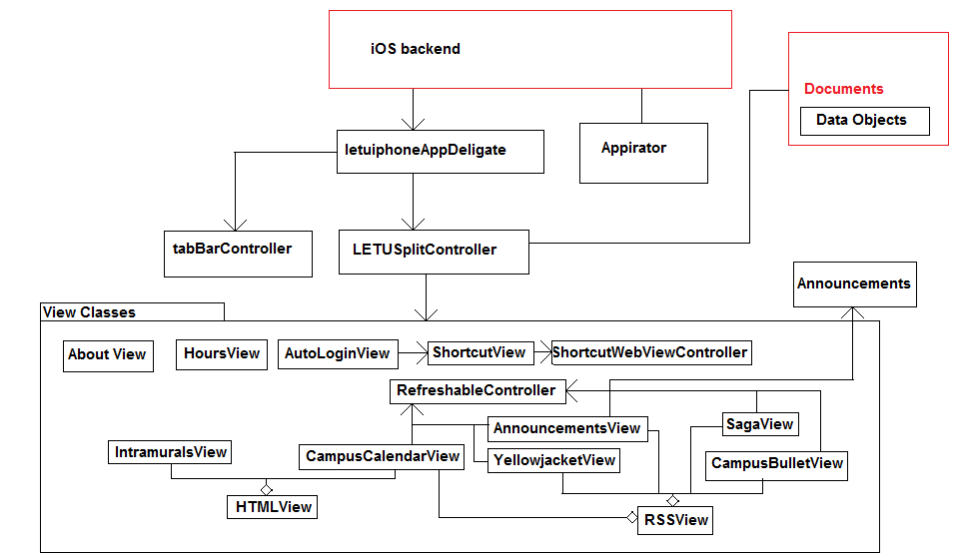
  - Appendix A – UML(-esque) Class Diagram

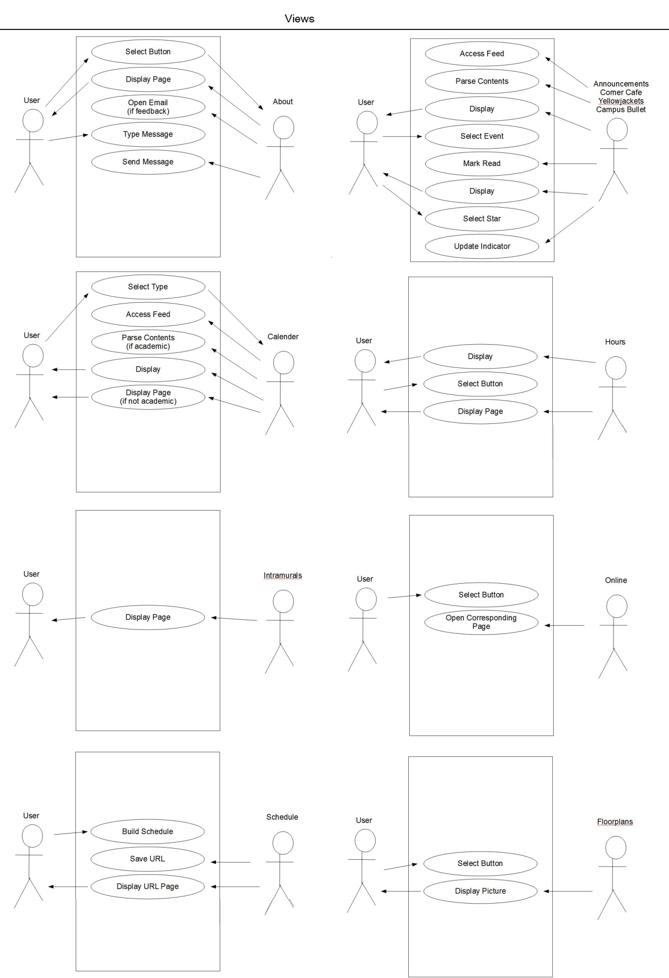
  - Appendix B – Use Case Diagram
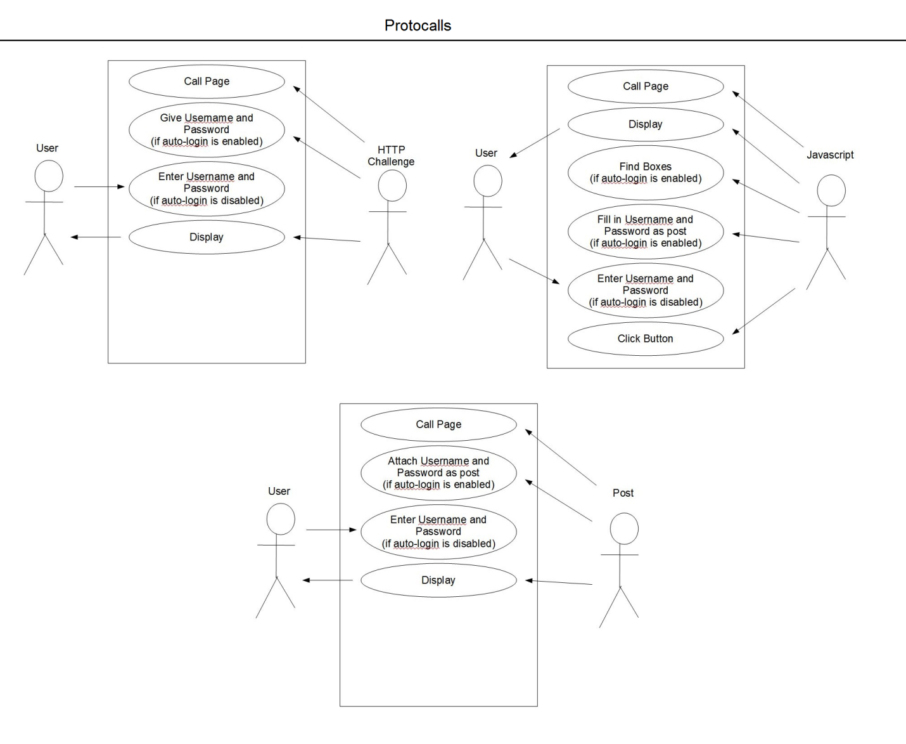
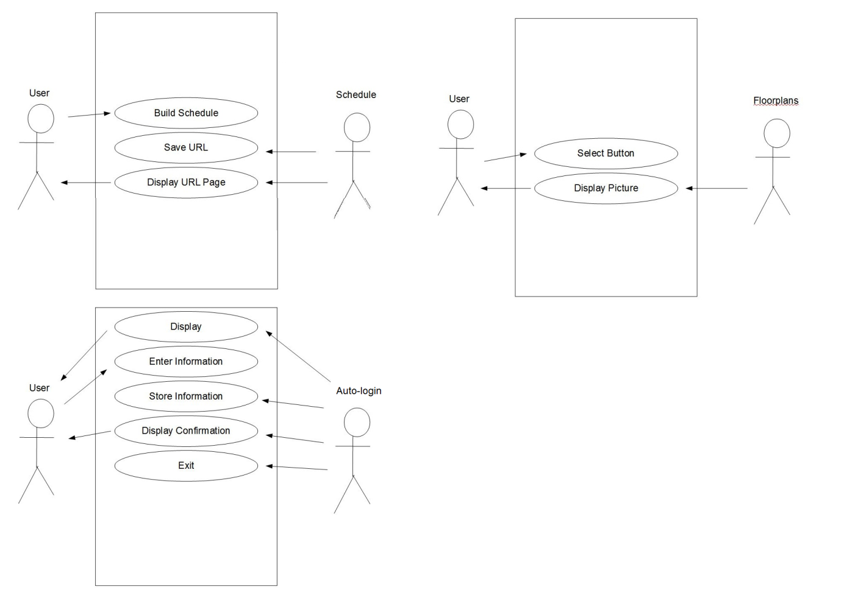

  - Appendix C – Miscellaneous Charts and Diagrams
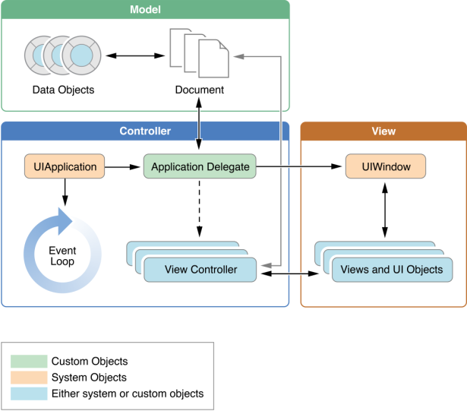
    - Model Controller View Diagram

